Distributed Web Crawler
CSE 5306 Spring 2015, Section 1

Team Members

Nishanth Terikere Vasudeva
1001011898
nishanth.terikerevasudeva@mavs.uta.edu

Puneeth Umesh Bharadwaj
1001106478
puneeth.bharadwaj@mavs.uta.edu

Tarun Ande
1001108289
tarun.ande@mavs.uta.edu

Introduction

A web crawler is a program or automated script which browses the World Wide Web in a methodical, automated manner. Web crawlers are mainly used to create a copy of all the visited pages for later processing by a search engine that will index the downloaded pages to provide fast searches.

Crawlers can validate hyperlinks and HTML code. They can also be used for web scraping. Also, crawlers can be used to gather specific types of information from Web pages, such as harvesting e-mail addresses
Background:

Web crawlers visit internet applications, collect data, and learn about new web pages from visited pages. Web crawlers have a long and interesting history. Early web crawlers collected statistics about the web. In addition to collecting statistics about the web and indexing the applications for search engines, modern crawlers can be used to perform accessibility and vulnerability checks on the application.

Objective of the project:

The main aim of this project is to implement a web crawler is distributed level.

Expected end product:
An expected end product of this project is an application that accepts main URL from the end user and crawl that user provided URL and to generate processes and divide work among the generated processes to crawl the results further.
Brief summary:

A python application using beautiful soup to build a web crawler which crawls the websites on a distributed level.

Functionalities:

- Provides the user with a input field to enter a website address.
- Retrieves website content.
- Retrieves all hyperlinks.
- List the hyperlinks.
Contents in the proposal document

- Introduction
  - Background
  - Objective of the project
  - Expected end product
  - Brief summary
  - Functionalities
- Related Work
- System Overview
- Detailed Design
- Implementation
- Theoretical/Simulation Study
- Future Work
- References

Related Work

- Bingbot is the name of Microsoft's Bing webcrawler. It replaced Msnbot.

- Googlebot is described in some detail, but the reference is only about an early version of its architecture, which was based in C++ and Python. The crawler was integrated with the indexing process, because text parsing was done for full-text indexing and also for URL extraction. There is a URL server that sends lists of URLs to be fetched by several crawling processes. During parsing, the URLs found were passed to a URL server that checked if the URL has been previously seen. If not, the URL was added to the queue of the URL server.

- WebCrawler was used to build the first publicly available full-text index of a subset of the Web. It was based on lib-WWW to download pages, and another program to parse and order URLs for breadth-first exploration of the Web graph. It also included a real-time crawler that followed links based on the similarity of the anchor text with the provided query.
- Scrapy, an open source webcrawler framework, written in python (licensed under BSD).

System Overview

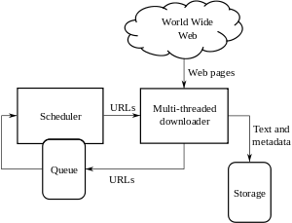

Architecture of basic web crawler

A brief discussion of each component

- Scheduler Sends the URLs to the MTD.
- Multi-threaded Downloader (MTD) downloads the text and metadata and stores in a database or a text file. It retrieves all the URLs from the website content and sends to the Queue.

Components interact with each other using multi-threaded IPC.
Detailed Design

Multiple instances of the web crawlers should be generated dynamically based on the architecture of the website to be crawled and a master is required to organize the generated threads and dispatched worker threads
Challenges

- The large volume implies that the crawler can only download a limited number of the Web pages within a given time, so it needs to prioritize its downloads. The high rate of change implies that the pages might have already been updated or even deleted.

- Quick expansion of the web, and the complexity added to web applications have made the process of crawling a very challenging one. Throughout the history of web crawling many researchers and industrial groups addressed different issues and challenges that web crawlers face.

- Performing an exhaustive crawl to reduce the time and cost of crawling is a challenging question. Additionally capturing the model of a modern web application and extracting data from it automatically is another open question.

All the components in the system interact through multi threading and Inter Process communication

Implementation

The project will be implemented in python. Different team members will be developing different scripts for crawling, managing of threads, and communications between processes for the development phase of the applications. During the testing phase of the project each member will test the modules which they did not develop.

Theoretical/Simulation Study
Communication overhead:

The main overhead is the internal communication between the processes as it is a distributed crawler. And also the communication between the web page and the individual process.
Storage overhead:

All the hyperlinks have to be stored. Some web pages may have indefinite number of web pages within them. Thus storage calculation theoretically is tedious. If a node with limited file space is allotted to the distributed system, it could to the failure of the node or optimal performance may not be retrieved out of the node.
Computational overhead:

Crawler a web site can be exhaustive and never ending depending upon the structure of the website that needs to be crawled.
Other possibilities:

The idea is to use JSON objects to interchange the results between the processes. Many other data types that could optimal for this system could be used.

Simulation Study:

A sample crawling script has been developed in python to observe how crawling works according to the structure of the web site, An URL from the University of Texas, Arlington has been Crawler and output has been observed.

Sample URL

http://www.uta.edu/uta/alpha-index.php

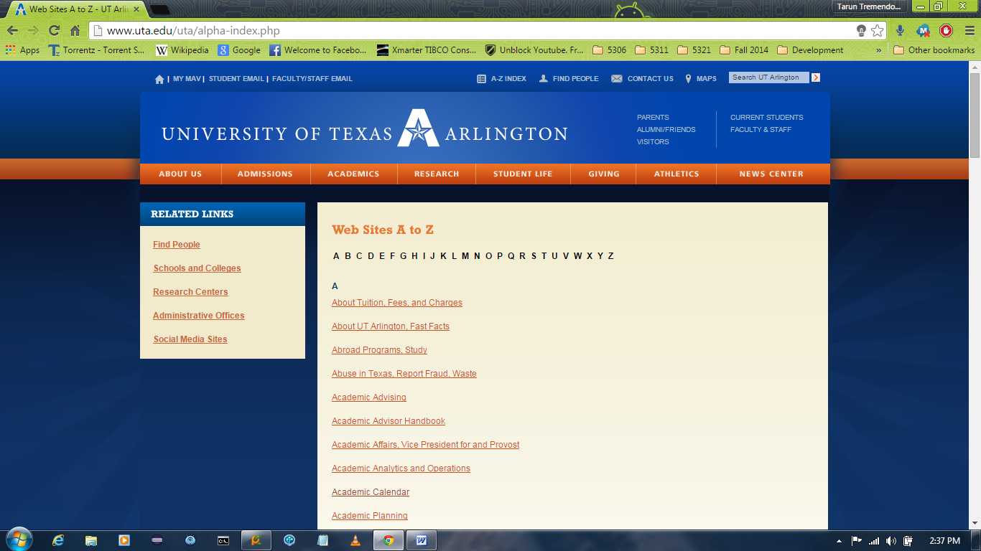

Sample Script

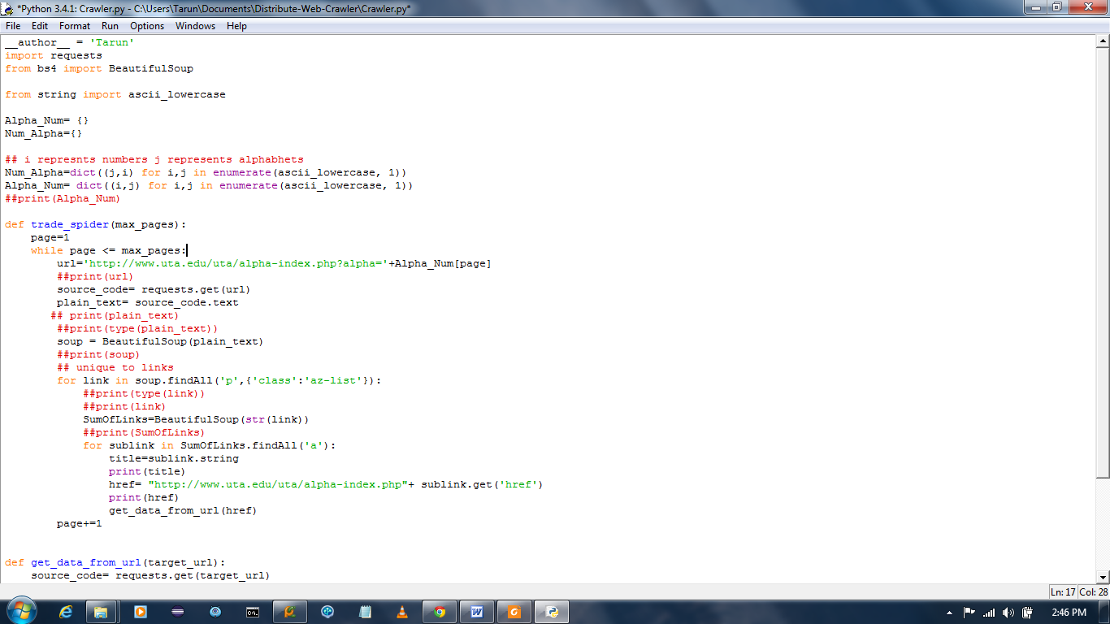

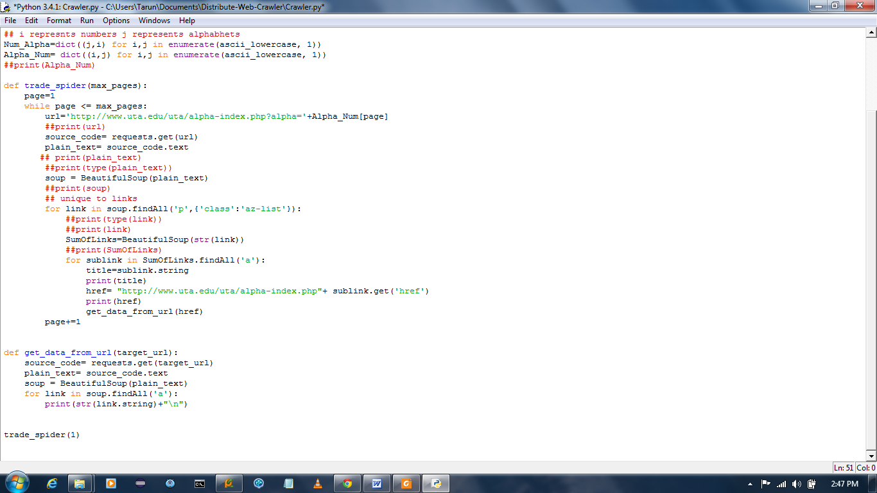

Observed Output

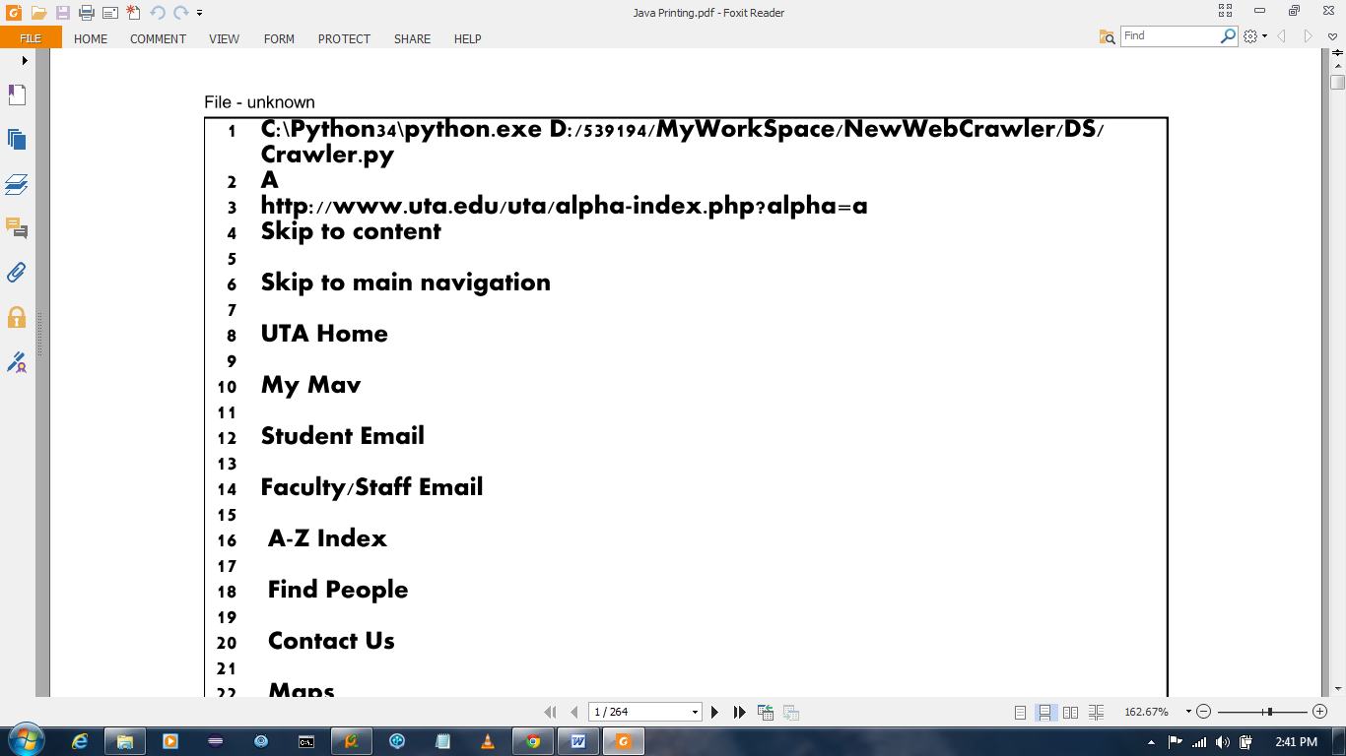

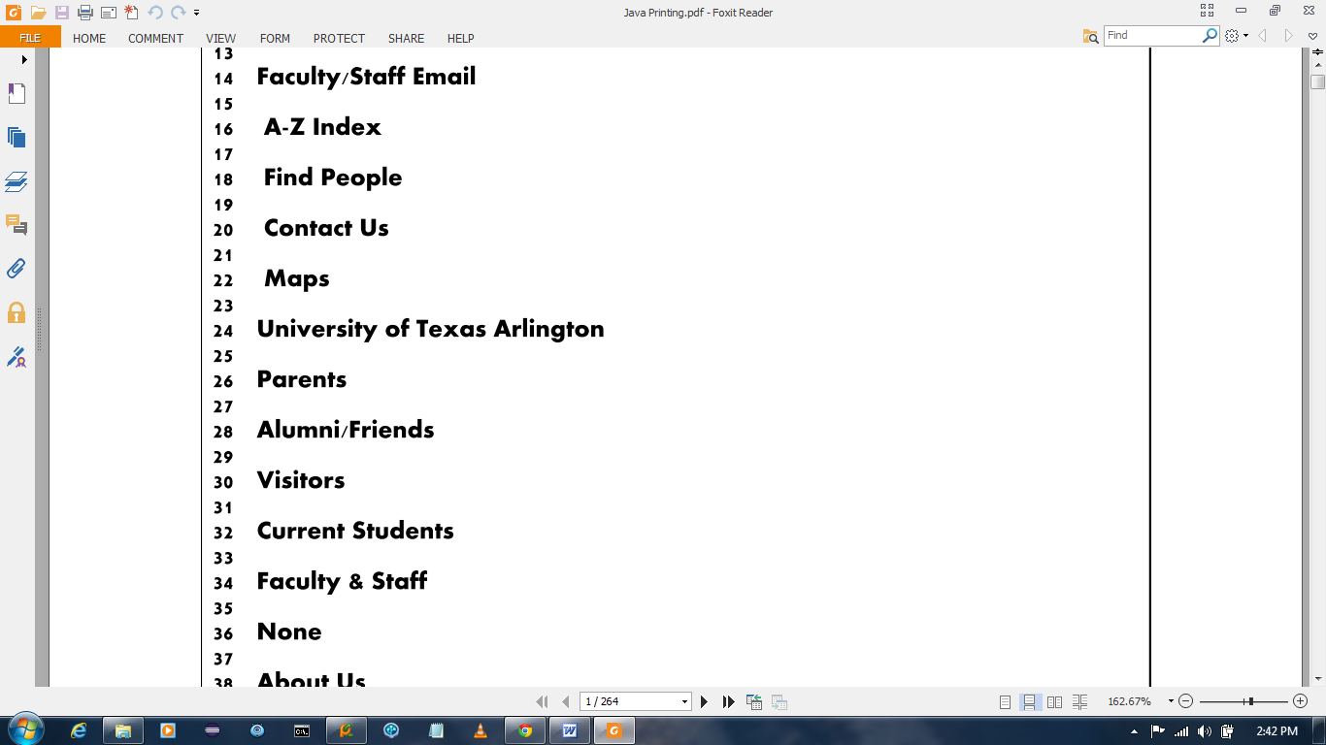

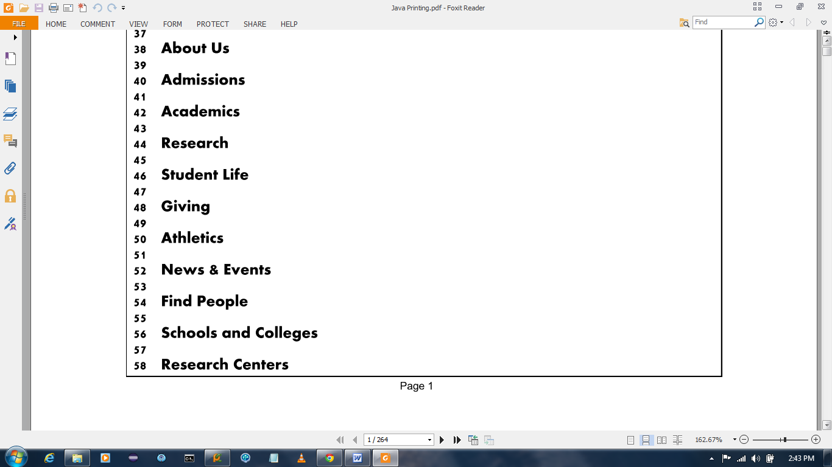

Future Work

Data bases and cloud services can be used for storing results and ranking the most visited URL

References
http://en.wikipedia.org/wiki/Web_crawler
http://www.sciencedaily.com/articles/w/web_crawler.htm
A Brief History of Web Crawlers

